# Issue description

Can you please check why OBD 820079551 is not replicating to Mohebi TEST.

Attached is the EDI file. Our usual practice is to do ASN receipt against OBD and only OBD replicates to 3PL when supplier does Goods issue. Only in case where OBD is not visible PO is pushed manually to 3PL.

However in the below testing, 2 messages have been triggered automatically from Nestle – One for PO and Second one for OBD from Nestle. As a result PO 4520299088 has replicated.

We however want the OBD replicated and want your support to understand why OBD 820079551 is not replicating to Mohebi TEST

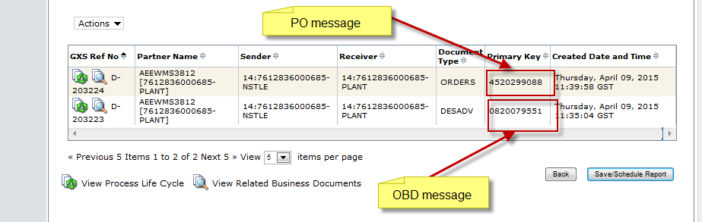

# EDI file for OBD

UNA:+.?   
UNB+UNOC:3+7612836000685-NSTLE:14+7612836000685-PLANT:14+150409:0735+4595++++++1  
UNH+459500001+DESADV:D:96A:EN:EAN005  
BGM+351+0820079551+9  
DTM+11:201504090822:203  
DTM+17:201504151711:203  
DTM+137:201504090735:203  
DTM+64:1504151711:713  
RFF+LO:0820079551  
RFF+ZCO:X  
RFF+ZFP: 0.00  
NAD+SF+6298007000015::9  
NAD+ST+7612836000685::9  
TDT+20++30+31+::9+++:::MEL66  
CPS+1  
PAC+1  
PCI+33E  
GIN+BJ+350103472321208281  
LIN+1++05000189009318:EN  
PIA+1+07:PV+05217392:SA  
PIA+4+000000000005217392:SA  
PIA+1+5000189009318:EN  
PIA+1+001007:IN  
QTY+12:180:CS  
QTY+21:180:CS  
QTY+265:12  
DLM+++0::9  
DTM+36:20160409:102  
DTM+361:20160409:102  
RFF+VN:4520299088:000010  
RFF+AAJ:0820079551:000010  
RFF+ON:LDP5502839  
RFF+ZFP: 0.00  
RFF+SS:AFTER EIGHT Carton 12x200g XI  
PCI+36E  
GIN+BX+090415  
UNT+35+459500001  
UNZ+1+4595